Scape from Mon

**Revision History**

|  |  |  |  |
| --- | --- | --- | --- |
| **Date** | **Version** | **Description** | **Author** |
| 01/04/2022 | 1.0 | Draft 1 | SCAPE FROM MON |
| 10/04/2022 | 2.0 | Version 2.0 | SCAPE FROM MON |
| 28/04/2022 | 3.0 | Version 3.0 | SCAPE FROM MON |

1. **Use Case Diagram**

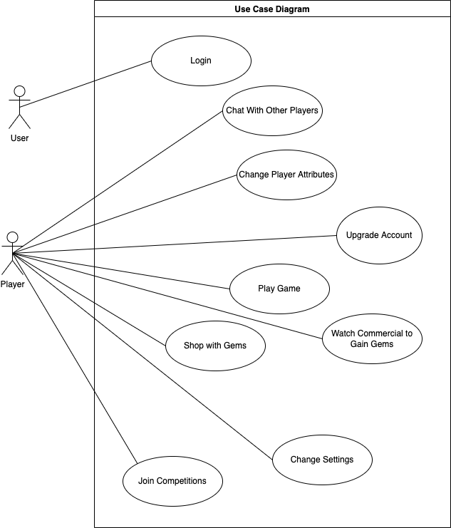

1. **Detailed Description the Use Cases**

Use Case: Play Game

**Scope:** Scape From Mon

**Level:** User goal

**Primary Actor:** Player

# Stakeholder and Interests:

## Player: Main character of the game. An astronaut from the planet called “Piffia”. On the planet “Mon” right now. Wants to go back to its own planet Piffia. Is responsible for solving the puzzles and gathering pieces to create the space shuttle which can take it back to its own planet.

* Project Financer: Wants the game to be played so smoothly, so that the money spent on the game won’t be for nothing.
* Distributor: Wants the game to be played without any problems so that its publications will get demanded.

# Preconditions: The User must be logged in. (For the first release game will be played without being logged in. In further iterations, login will be mandatory.)

# Post-conditions:

# *Level Successfully Completed:* The player has received a success message and passes the next level.

# *Game End:* The player plays the last level and the game shows a video about the journey of the space shuttle.

## *Level Failed:* The player has received a failure message and replays the current level.

# Main Success Scenario (or Basic Flow)

1. The player selects the level it is lastly left.
2. The player solves the puzzle belonging to this level and overcomes the obstacles.
3. The player passes to the next level.
4. Step 3 and 4 repeated.

# Extensions (or Alternative Flows)

## Play Without Login:

For the first few iterations it will be available for the user playing the game without the login.

1. The game opened with main screen with shows the levels

*Flow goes on from step 1 in the Main Scenario.*

## Play the Last Level:

## *First two steps in the Main Scenario are realized.*

1. There is no more level left to play.
2. The player selects the “Start Journey Button”.
3. A video is played which shows the player’s formed space shuttle arriving at its home planet.

## Level Fails

1. The player selects the level it is lastly left.
2. The player fails because of an obstacle.
3. The level is replayed.
4. The Player solves the puzzle belonging to this level and overcomes the obstacles.
5. The Player passes to the next level.
6. Step 3 and 4 repeated.

# Frequency of Occurrence: Nearly continuous

Use Case: Change Settings

**Scope:** Scape From Mon

**Level:** User goal

**Primary Actor:** Player

# Stakeholder and Interests:

* Player: Wants to change the specific settings of the game like turning off the sound or switching language to Turkish etc.

# Preconditions: The User must be logged in to see the “Settings” screen.

# Post-conditions:

## *“On” Option Selected for Sound:* Game of the sound is turned on.

## *“Off” Option Selected for Sound*: Game of the sound is turned off.

* *English Language Selected:*Scripts in the game are English.
* *Turkish Language Selected:*Scripts in the game are English.

# Main Success Scenario (or Basic Flow)

1. The player clicks the Settings button.
2. The player selects the setting and displays the options for that setting.
3. The player selects an option.
4. Option is applied by the game.

# Extensions (or Alternative Flows)

## Change Sound Setting

*First two steps in the Main Scenario are realized.*

1. The player selects the Sound button and views the options.
2. The player selects “On” or “Off”.
3. The game turns on or turns off the sound according to the player’s selection.

## Change Language Setting

*First two steps in the Main Scenario are realized.*

1. The player selects the Language button and views the options.
2. The player selects “English” or “Turkish”.
3. The game changes the language in all scripts of the game according to the player’s selection.

# Frequency of Occurrence: Nearly continuous

Use Case: Login

**Scope:** Scape From Mon

**Level:** User goal

**Primary Actor:** Player

# Stakeholder and Interests:

* Players can login the system with their credentials.

# Preconditions: The User must have valid username and password.

# Post-conditions:

## *“Successful” login process reaching the game menu.*

## *“Un- Successful” login process has an error message from the game. Back to the login page.*

# Main Success Scenario (or Basic Flow)

1. The player enters username and password.
2. The player views main menu.

# Extensions (or Alternative Flows)

## Enter Valid username and password

*First two steps in the Main Scenario are realized.*

1. The player selects an option in the menu.
2. Option is applied by the game.

## Create an account

*First step in the Main Scenario is realized.*

1. The player cannot authorize

1. The player clicks create account button
2. The player view creates view page
3. The player enters email full name password and confirm password fields.

# Frequency of Occurrence: Nearly continuous

**Use Case: Chat with Other Players**

**Scope:** Scape From Mon

**Level:** User goal

**Primary Actor:** Player

# Stakeholder and Interests:

* Player: Wants to chat with each other through the “Scape From Mon”.

# Preconditions: The User must be logged in to see the “Chat Box Tab” screen.

# Post-conditions:

* *Chat Box Tab Selected:*The player has a chat with any player from the game.

# Main Success Scenario (or Basic Flow)

1. The player clicks the Chat Box Tab.

1. The player selects the any player in the list.
2. The player selects a player.
3. The player starts to chat with selected player.

# Extensions (or Alternative Flows)

## Select a player in the list

*First two steps in the Main Scenario are realized.*

1. The player selects the online players in the list.

# Frequency of Occurrence: Nearly continuous

**Use Case: Change Player Attributes**

**Scope:** Scape From Mon

**Level:** User goal

**Primary Actor:** Player

# Stakeholder and Interests:

* Player: Wants to change player attributes in “Scape From Mon”.

# Preconditions: The player must be logged in to see the “Options”.

# Post-conditions:

* *Options are selected:*The player can be updated are the name and the skin of the astronaut.

# Main Success Scenario (or Basic Flow)

1. The player clicks options.

2. The player enters a new name for the main character.

3. The player changes the skin of the main character.

# Extensions (or Alternative Flows)

## Change the skin in the list

*Third step in the Main Scenario is realized.*

1. The player only has two options white and black.

# Frequency of Occurrence: Nearly continuous

**Use Case: Watch Commercial to Gain Gems**

**Scope:** Scape From Mon

**Level:** User goal

**Primary Actor:** Player

# Stakeholder and Interests:

* Player: Wants to watch commercial willingly in “Scape From Mon”.

# Preconditions: The User must be logged in.

# Post-conditions:

* *Options are selected:*The player can be updated commercial options.

# Main Success Scenario (or Basic Flow)

1. The player clicks commercial options.

2. The player selected to watch commercial willingly.

# Extensions (or Alternative Flows)

## Changing commercial options turn willingly.

*Second step in the Main Scenario is realized.*

1. The player obtains some gems as reward.

## Changing commercial options turn off willingly.

*Second step in the Main Scenario is realized.*

1. While Player playing the game, after some milestones like level pass or finding an item, a commercial will be shown to the Player. When the commercial ends, coins or gems will be added to the user's ownings.

# Frequency of Occurrence: Nearly continuous

**Use Case: Shop with Gems**

**Scope:** Scape From Mon

**Level:** User goal

**Primary Actor:** Player

# Stakeholder and Interests:

* Player: Wants to buy some items using the gems they own in “Scape From Mon”.

# Preconditions: The User must be logged in.

# Post-conditions:

* *Entered the store:*The player can buy some items using them in the game.

# Main Success Scenario (or Basic Flow)

1. The player enters the store.

2. The player selects gems – coins or diamonds.

3. The items are calculated prices in the basket.

4. The player buy them and start using.

# Extensions (or Alternative Flows)

## Buying item related space shuttle.

*First four steps in the Main Scenario are realized.*

1. The player using it with solving puzzles for the astronauts needs.

# Frequency of Occurrence: Nearly continuous

**Use Case: Join Competitions**

**Scope:** Scape From Mon

**Level:** User goal

**Primary Actor:** Player

# Stakeholder and Interests:

* Player: Wants to play some competitions “Scape From Mon”.

# Preconditions: The User must be logged in.

# Post-conditions:

* *Entered the competition challenge:*The player gets additional gems and items for building the space shuttle.

# Main Success Scenario (or Basic Flow)

1. The player enters the competition.

2. The player solves additional puzzles.

# Extensions (or Alternative Flows)

## Attending the competition.

*First two steps in the Main Scenario are realized.*

1. End of the competition’s players are showed in the list ordered in the direction of their success.

# Frequency of Occurrence: Nearly continuous

**Use Case: Upgrade Account**

**Scope:** Scape From Mon

**Level:** User goal

**Primary Actor:** Player

# Stakeholder and Interests:

* Player: can upgrade its account in a way.

# Preconditions: The User do account settings in-app purchase.

# Post-conditions:

* *The user buys with game upgrade account:*Player can play the game without any interruptions because of commercials.

# Main Success Scenario (or Basic Flow)

1. The player enters the app store.

2. The player selects upgrade account for the game.

3. The player buy it and start using.

# Extensions (or Alternative Flows)

# Frequency of Occurrence: Nearly continuous